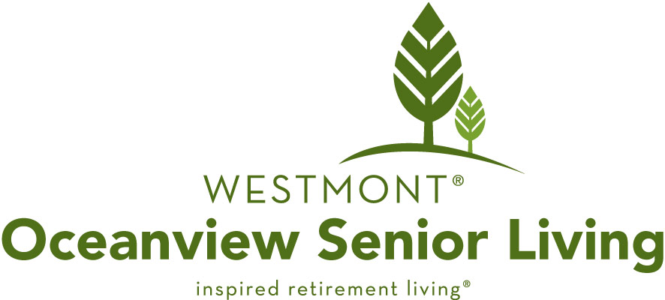

Professional Referral Program

Do you know someone who could benefit from the lifestyle and services of Newport’s premiere retirement community, including independent living and assisted living? We understand how much you care about your clients and we would like to continue that level of high-quality service by introducing your clients to Oceanview Senior Living, a full-service, Westmont Living retirement community.

We offer cash incentives for new residents who are referred to us by their attorneys, real estate agents, financial advisors, leasing agents, accountant and other caring professionals. Simply fill out the form below and return it to us. If the referral chooses to move in to Oceanview, you will receive $1,000 cash as a “thank you” from us or, if you prefer, we will make a donation of the same amount to the charity of your choice and in honor of the name you specify.

Referral’s Name:

Referral’s Address:

Referral’s Phone: Email:
Your Name: Eureka Cemetery & Mausoleum Association Email: ECAOR@outlook.com

Your Phone: 541.265.7282 Address:1101 NE Yaquina Heights Drive, PO Box 1762, Newport, OR 97365

Your Relationship to Referral: Friend

*Please note: This referral information must be received prior to or at the time of the first visit of a new resident. Qualified referral means anyone who tours Oceanview Senior Living and moves in as a permanent resident within 90 days of their initial tour. One-time payment for each qualified referral. Payments will be made after referral has lived in the community for 30 days. This promotion is subject to change without notice.
Oceanview Senior Living

525 NE 71st Street Newport, OR 97365

Phone: (541) 574-0550 ■ Fax: (541) 574-7713

crdnewport@westmontliving.com
www.OceanviewSeniorLiving.com

